**/*ASSIGNMENT 2*/**

**/* USE SUPERSTORES DATABASE */**

**#task1**

1. **Describe the data in hand in your own words.**

THIS DATA IS OF A SUPERSTORES .IN THIS WE CAN HAVE FIVE TABLES

OF

* CUSTOMER DETAILS
* MARKETING FACTOR
* ORDER DIMENTION
* PRODUCT DIMENTION
* SHIPPING DIMENTION

1. **Identify and list the Primary Keys and Foreign Keys for this dataset provided to you(In case you don’t find either primary or foreign key, then specially mention this in your answer)**

**#task2**

**1. Write a query to display the Customer_Name and Customer Segment using alias**

**name “Customer Name", "Customer Segment" from table Cust_dimen.**

select Customer_Name as `Customer Name`,

Customer_Segment as `Customer Segment`

from superstores.cust_dimen;

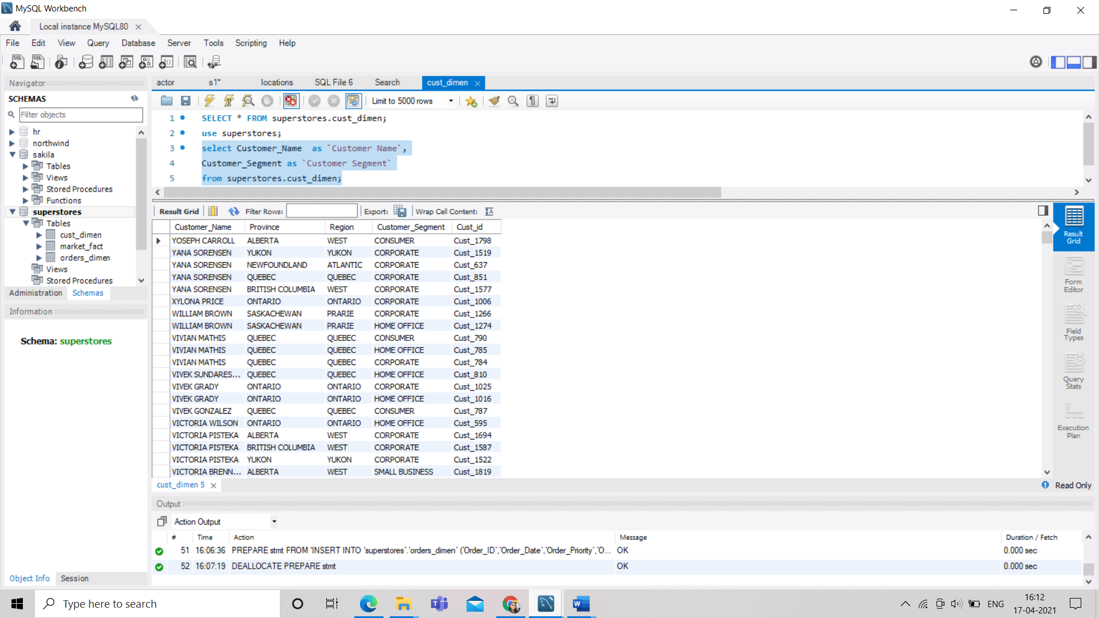

**2. Write a query to find all the details of the customer from the table cust_dimen**

**order by desc.**

SELECT

*

FROM

superstores.cust_dimen

ORDER BY 1 DESC;

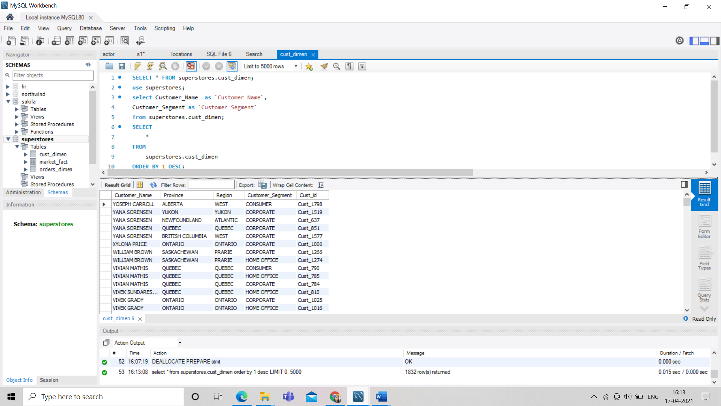

**3. Write a query to get the Order ID, Order date from table orders_dimen where**

**‘Order Priority’ is high.**

SELECT

Order_ID, Order_Date

FROM

superstores.orders_dimen

WHERE

Order_Priority = 'HIGH';

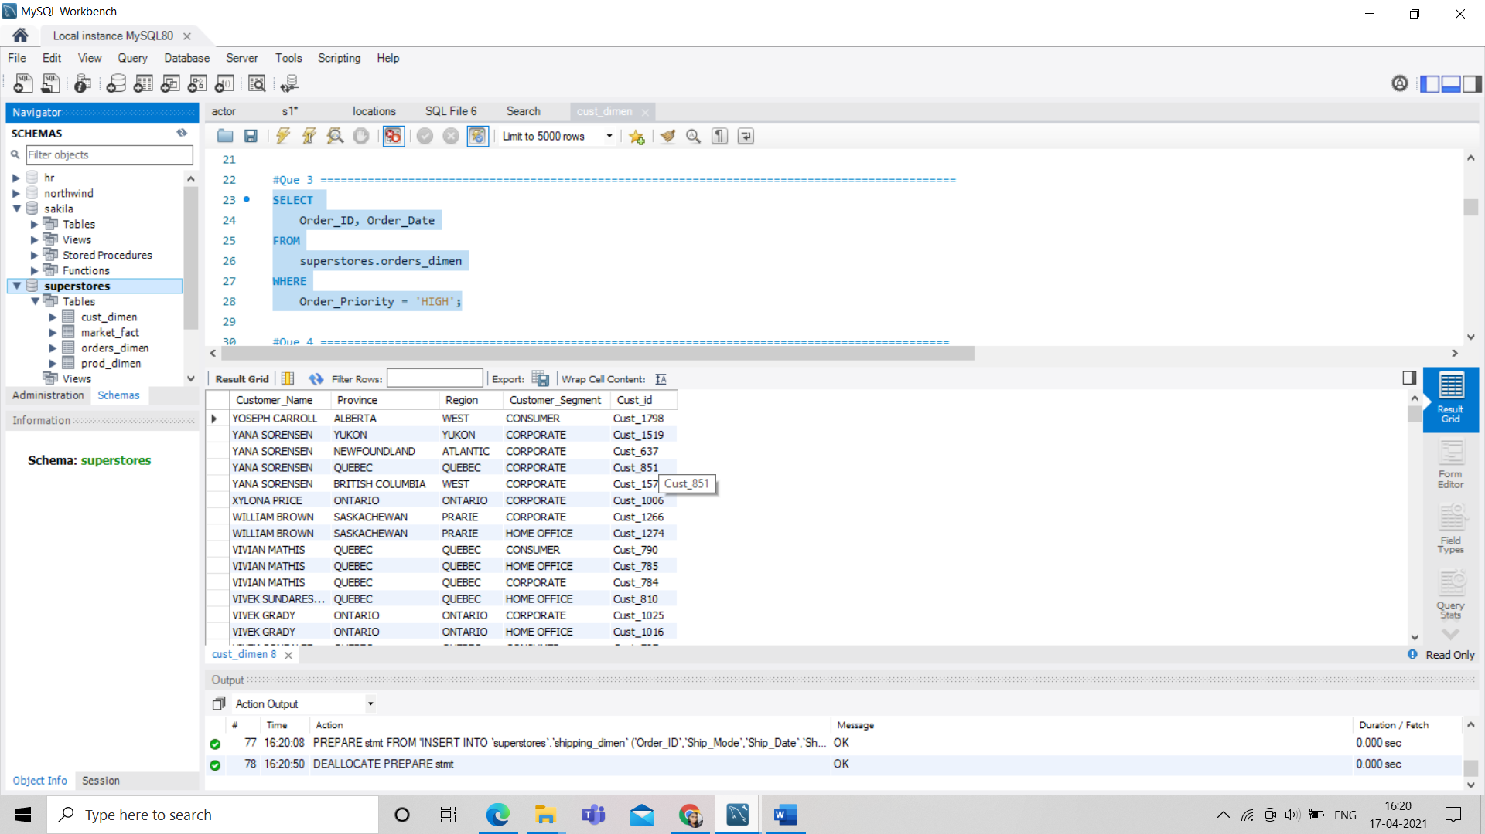

**4. Find the total and the average sales (display total_sales and avg_sales)**

SELECT

SUM(Sales) AS total_sales, AVG(Sales) AS avg_sales

FROM

superstores.market_fact;

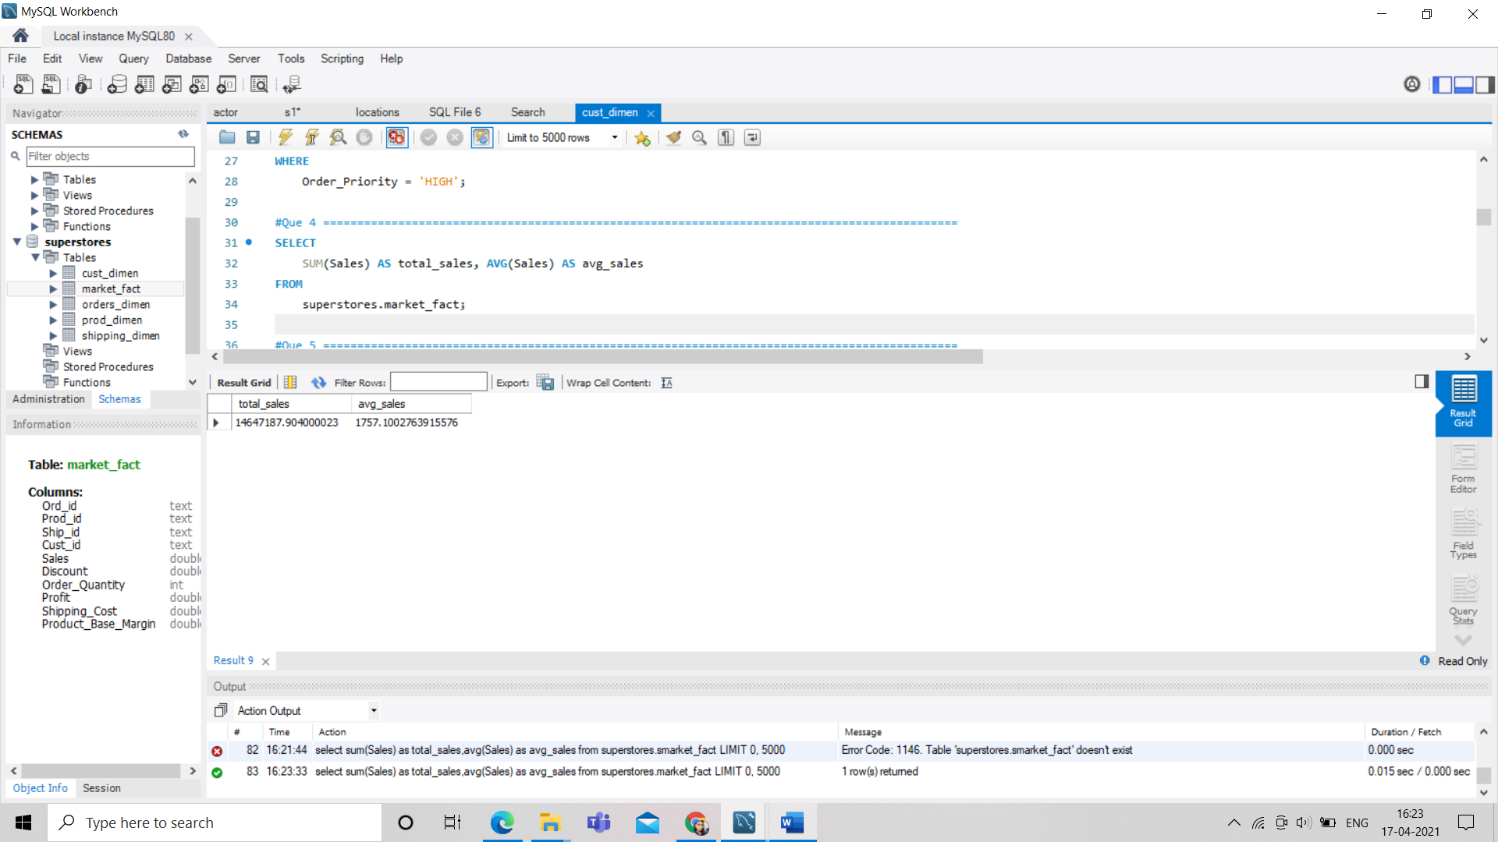

**5. Write a query to get the maximum and minimum sales from maket_fact table.**

SELECT

MAX(Sales) AS max_sale, MIN(Sales) AS min_sale

FROM

superstores.market_fact;

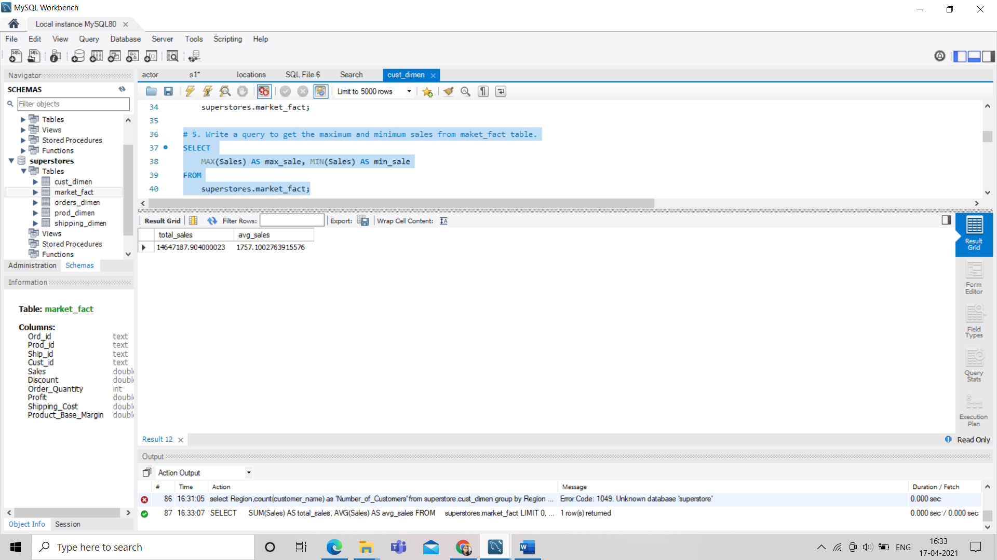

**6. Display the number of customers in each region in decreasing order of**

**no_of_customers. The result should contain columns Region, no_of_customers.**

SELECT

Region, COUNT(Customer_Name) AS 'Number_of_Customers'

FROM

superstores.cust_dimen

GROUP BY Region

ORDER BY COUNT(Customer_Name) DESC;

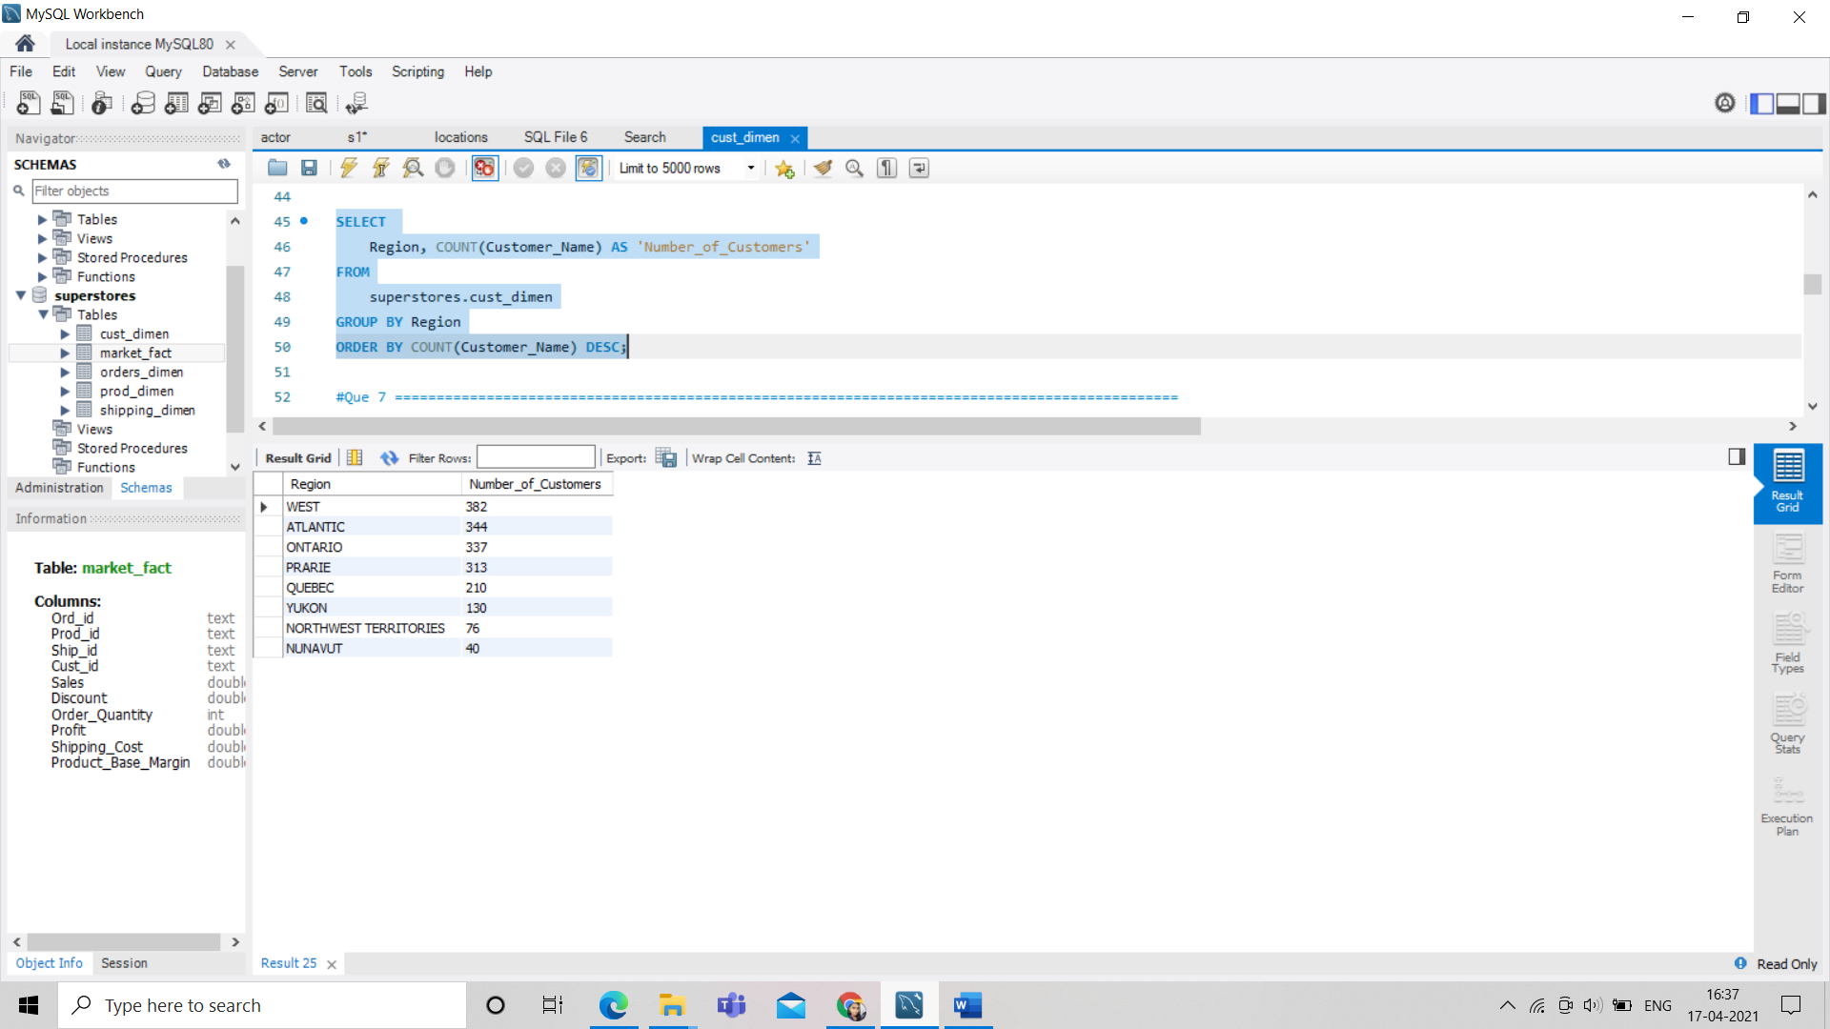

**7. Find the region having maximum customers (display the region name and**

**max(no_of_customers)**

SELECT

Region, COUNT(customer_name) AS 'Number_of_Customers'

FROM

superstore.cust_dimen

GROUP BY Region

ORDER BY COUNT(Customer_Name) DESC

LIMIT 1;

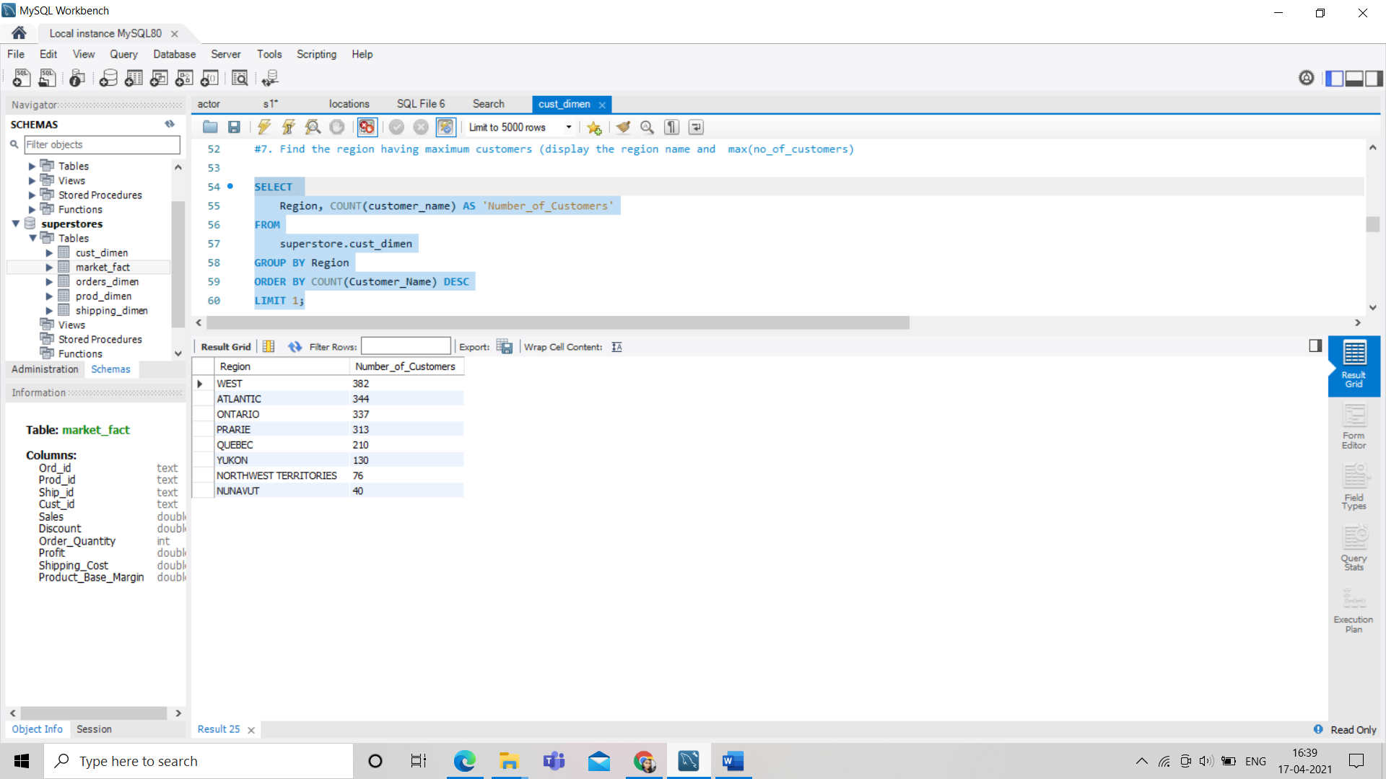

**8. Find all the customers from Atlantic region who have ever purchased ‘TABLES’**

**and the number of tables purchased (display the customer name, no_of_tables**

**purchased)**

SELECT

Customer_Name, COUNT(*) AS num_tables

FROM

superstores.market_fact s,

superstores.cust_dimen c,

superstores.prod_dimen p

WHERE

s.Cust_id = c.Cust_id

AND s.Prod_id = p.Prod_id

AND p.Product_Sub_Category = 'TABLES'

AND c.Region = 'ATLANTIC'

GROUP BY Customer_Name;

H1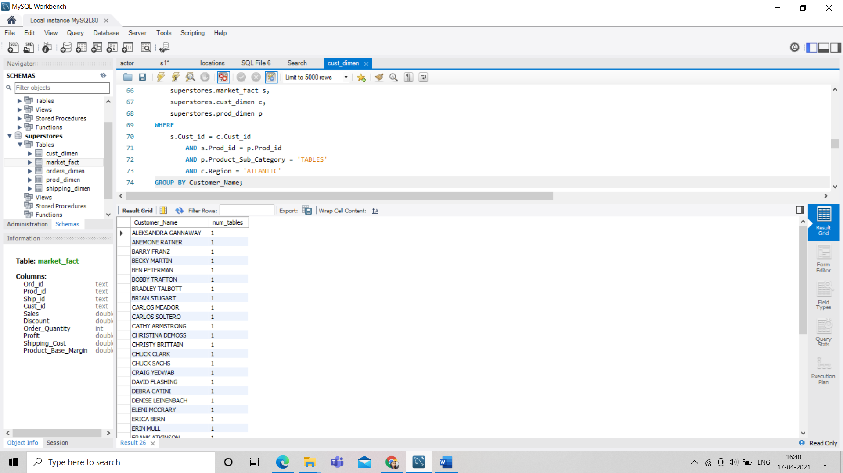

**9. Find all the customers from Ontario province who own Small Business. (display**

**the customer name, no of small business owners)**

SELECT

Customer_Name, COUNT(*) AS `no of small business owners`

FROM

superstores.cust_dimen

WHERE

Customer_Segment = 'SMALL BUSINESS'

AND Province = 'ONTARIO'

GROUP BY Customer_Name;

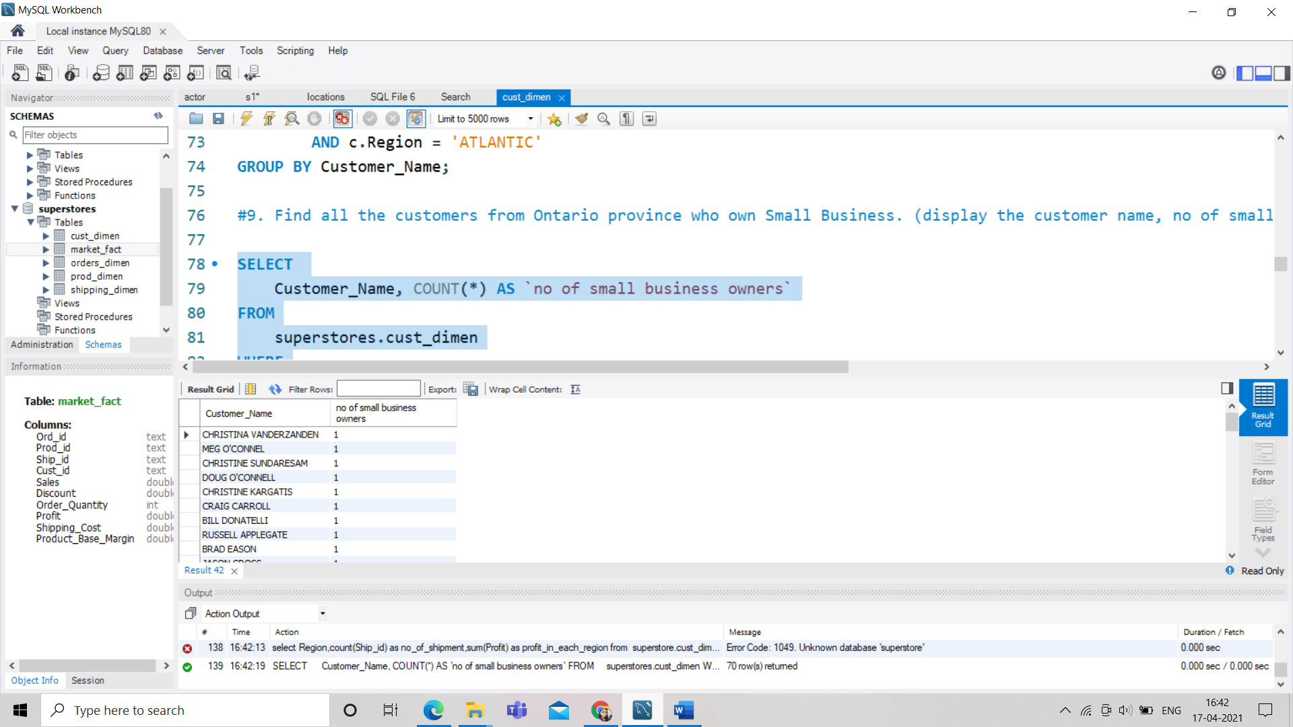

**10. Find the number and id of products sold in decreasing order of products sold**

**(display product id, no_of_products sold)**

SELECT

Prod_id, COUNT(*) AS `no_of_products sold`

FROM

superstores.market_fact

GROUP BY Prod_id

ORDER BY COUNT(`no_of_products sold`) DESC;

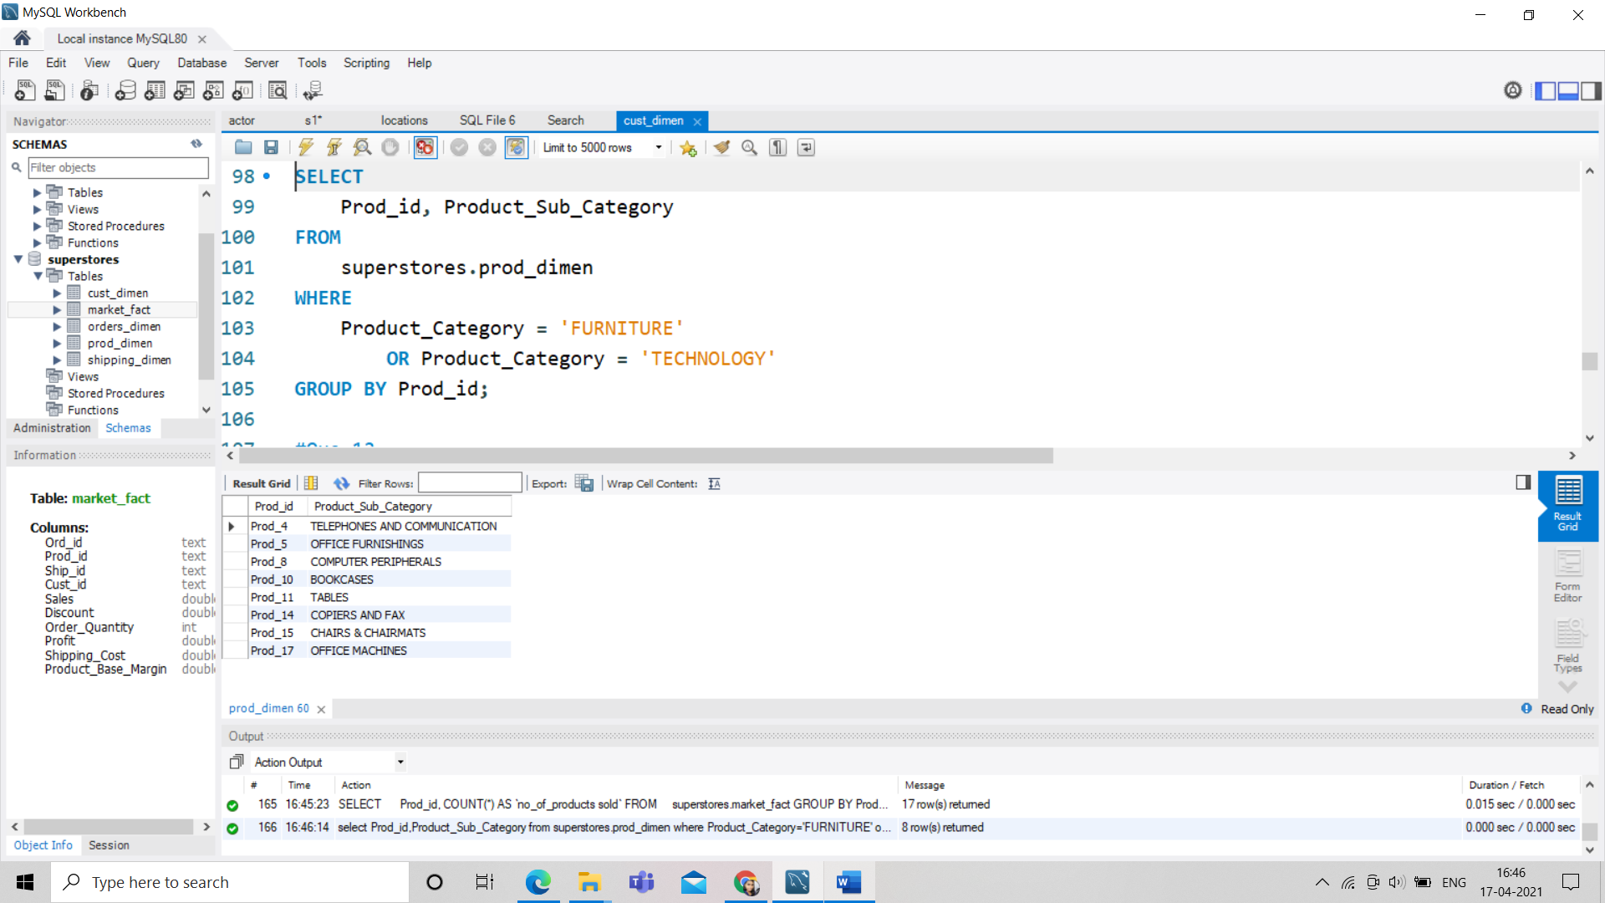

**11. Display product Id and product sub category whose produt category belongs to**

**Furniture and Technlogy. The result should contain columns product id, product**

**sub category.**

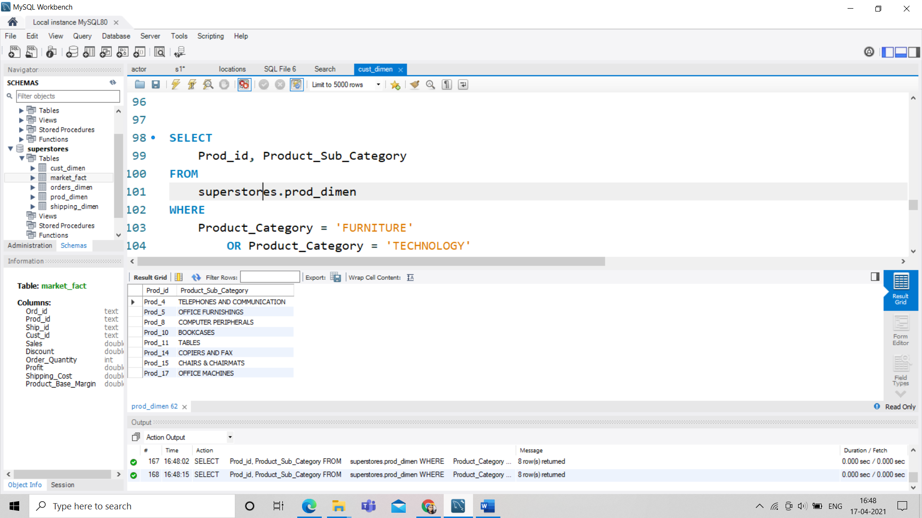

**12. Display the product categories in descending order of profits (display the product**

**category wise profits i.e. product_category, profits)?**

SELECT

Product_Category, Profit

FROM

superstores.market_fact s,

superstores.prod_dimen p

WHERE

s.Prod_id = p.Prod_id

GROUP BY Product_Category

ORDER BY Profit DESC;

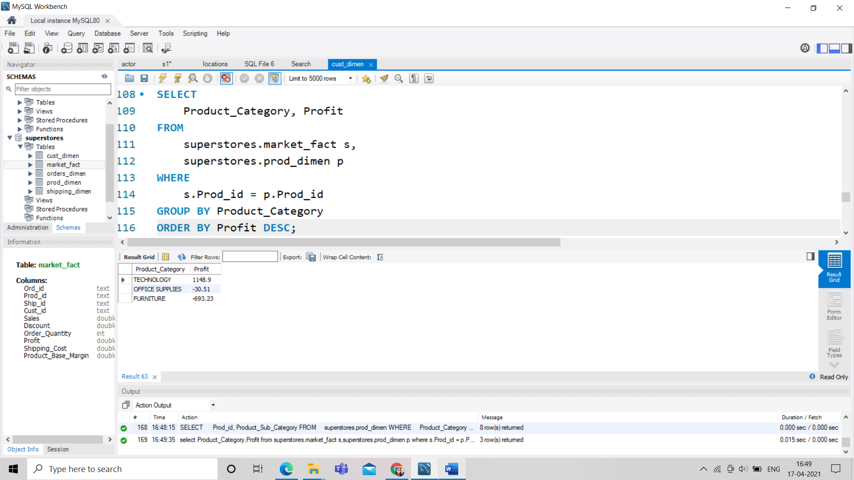

**13. Display the product category, product sub-category and the profit within each**

**subcategory in three columns.**

SELECT

Product_Category, Product_Sub_Category, Profit

FROM

superstores.market_fact s,

superstores.prod_dimen p

WHERE

s.Prod_id = p.Prod_id;

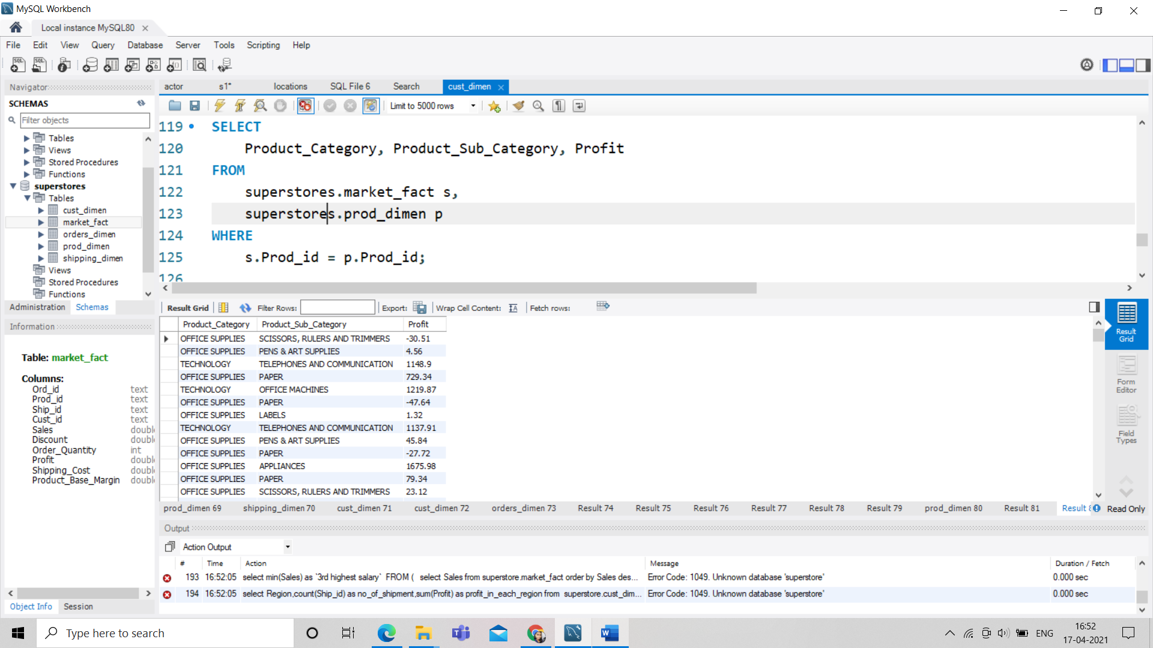

**14. Display the order date, order quantity and the sales for the order.**

SELECT

Order_Date, Order_Quantity, Sales

FROM

superstores.market_fact s,

superstores.orders_dimen c

WHERE

s.Ord_id = c.Ord_id;

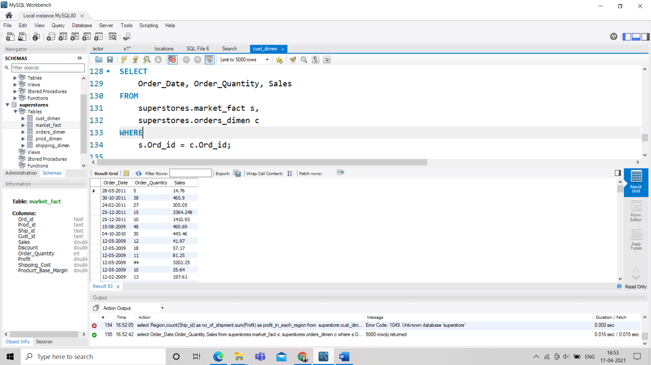

**15. Display the names of the customers whose name contains the**

**i) Second letter as ‘R’**

**ii) Fourth letter as ‘D’**

SELECT

Customer_Name

FROM

superstores.cust_dimen

WHERE

Customer_Name LIKE '_R%'

AND Customer_Name LIKE '___D%';

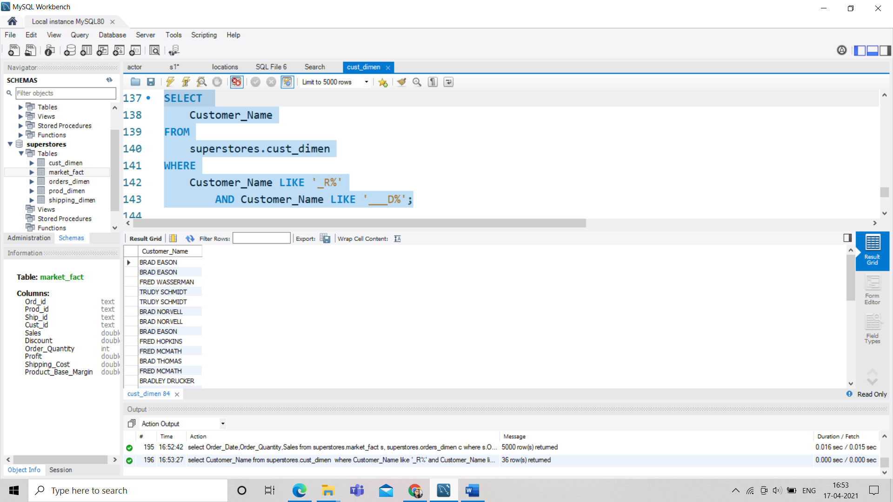

**16. Write a SQL query to to make a list with Cust_Id, Sales, Customer Name and**

**their region where sales are between 1000 and 5000.**

SELECT

c.Cust_id, s.Sales, c.Customer_Name, c.Region

FROM

superstores.market_fact s,

superstores.cust_dimen c

WHERE

s.Cust_id = c.Cust_id

AND Sales BETWEEN 1000 AND 5000;

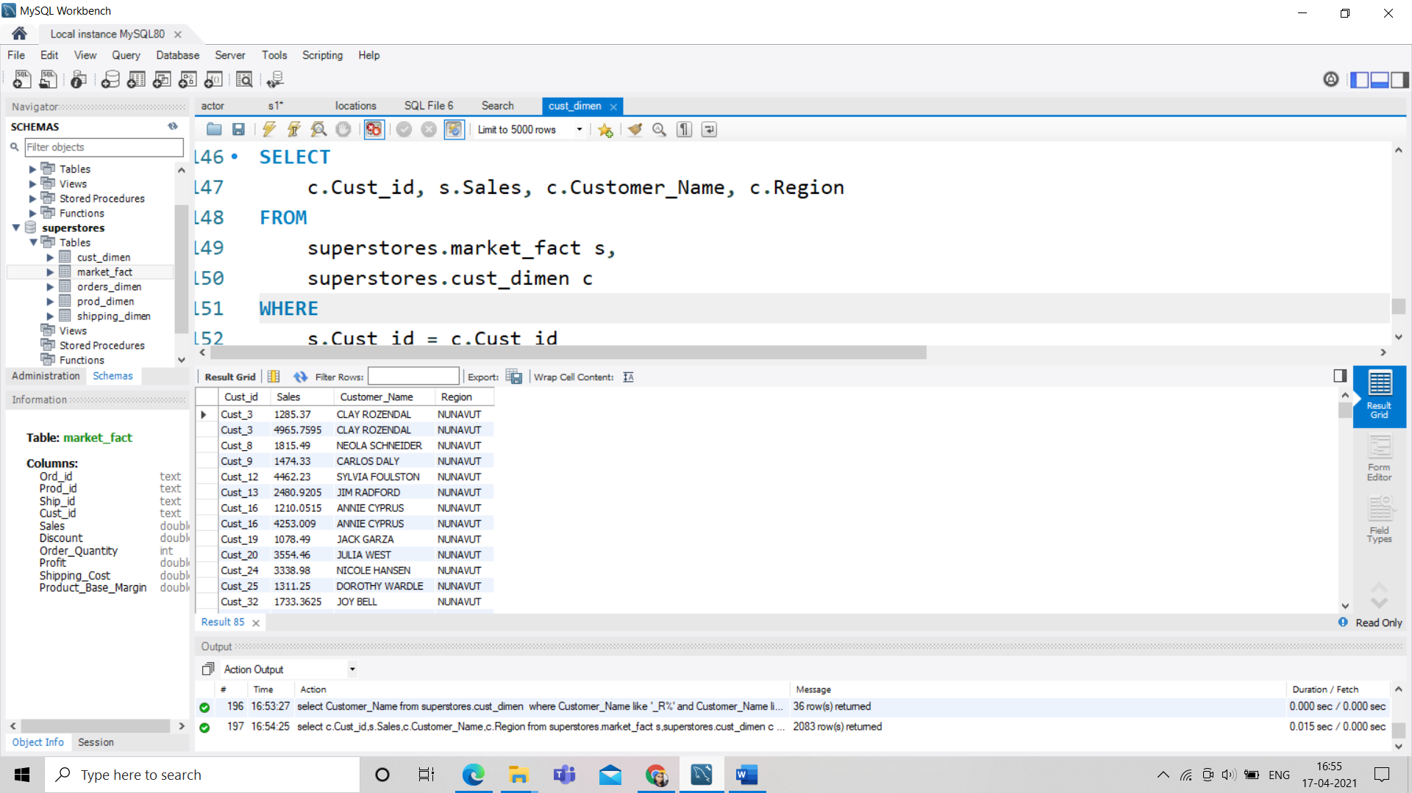

**17. Write a SQL query to find the 3rd highest sales.**

SELECT

MIN(Sales) AS `3rd highest salary`

FROM

(SELECT

Sales

FROM

superstores.market_fact

ORDER BY Sales DESC

LIMIT 3) AS a;

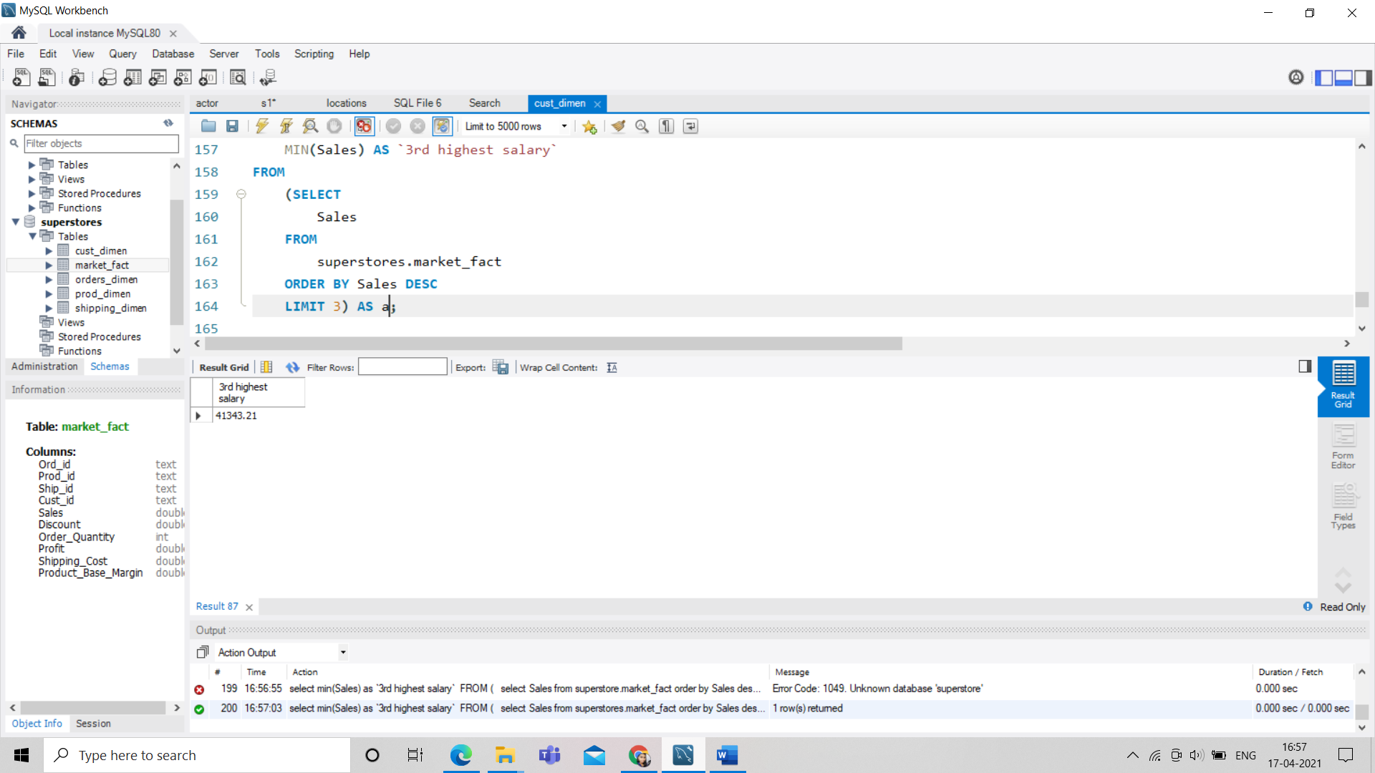

**18. Where is the least profitable product subcategory shipped the most? For the least**

**profitable product sub-category, display the region-wise no_of_shipments and the profit made in each region in decreasing order of profits (i.e. region,**

**no_of_shipments, profit_in_each_region)**

**SELECT**

**Region,**

**COUNT(Ship_id) AS no_of_shipment,**

**SUM(Profit) AS profit_in_each_region**

**FROM**

**superstores.cust_dimen c,**

**superstores.market_fact s,**

**superstores.prod_dimen p**

**WHERE**

**c.Cust_id = s.Cust_id**

**AND s.Prod_id = p.Prod_id**

**GROUP BY Region**

**ORDER BY profit_in_each_region ASC;**

